IPSI Case Study Summary Sheet

Please submit this form along with your case study. We ask that you keep your responses here as concise as possible. This information will be posted on the IPSI website unless otherwise requested. Please inform the IPSI Secretariat if there are any responses you would not like made public.
Basic Information
Title of case study (should be concise and within approximately 25 words)
A Project to Restore the Ecosystem through Integrated Management from the Mountains to the Sea in Kuki Area, Owase City
Submitting IPSI member organization(s)
Owase City
Other contributing organization(s) (IPSI members and/or non-members)
LY Corporation (IPSI non-member)
MITSUWA HOLDINGS CO., Ltd. (IPSI non-member)
Paramita, Inc. (IPSI non-member)
SEA VEGETABLE COMPANY (IPSI non-member)
Yamanari Co., Ltd. (IPSI non-member)
The Nature Conservation Society of Japan (IPSI non-member)
Author(s) and affiliation(s)
Tatsuya Ishikawa, Agriculture, Fisheries & Forestry Division, Owase City, Mie Prefecture
Format of case study (manuscript or audiovisual) | Manuscript | Language | English
Keywords (3-5 key concepts included in the case study)
forestry, ecosystem restoration , traditional knowledge , biodiversity, multi stakeholder participation
Date of submission (or update, if this is an update of an existing case study)
Web link (of the case study or lead organization if available for more information)

Geographical Information
Country (where site(s) or activities described in the case study are located – can be multiple, or even “global”)
Japan
Location(s) (within the country or countries – leave blank if specific location(s) cannot be identified)
Owase City, Mie Prefecture
Longitude/latitude or Google Maps link (if location is identified)
Google Map：https://maps.app.goo.gl/2XvYhrWFb2UXTNWm8
Ecosystem(s) (please place an “x” in all appropriate boxes)
Forest | X | Grassland |  | Agricultural |  | In-land water |  | Coastal | X
Dryland |  | Mountain | X | Urban/peri-urban |  | Other (Please specify) | X (Satoyama)
Socioeconomic and environmental characteristics of the area (within 50 words)
Owase City in southern Mie Prefecture covers 192.71 km² with 14,934 residents and is one of Japan's heaviest rainfall areas. Steep slopes from mountains (1,000-1,400m) extend into the sea and the coastline is complex rias. In each area, forestry, fisheries, and agriculture have been practiced, utilizing the mountain-to-sea ecosystem.

Description of human-nature interactions in the area (land-use, traditional resource management practices etc. – within 50 words)
Owase City mainly consists of Satoyama and Satoumi environments, with few pristine natural environments left. Traditional knowledge for sustainable resource use of local nature remains among the primary industry workers. Forestry as well as fisheries have been key industries since the Edo period.

Contents
Note: The following fields are used for information about activities described in the case study or the production of the case study itself, and contents may vary depending on the nature of the case study. For example, a case study about on-the-ground activities may include the rationale, objectives etc. for the activities; a case study about a SEPLS-related policy may describe the policymaking process; or a case study describing a SEPLS may address particular practices used there. Please make an effort to fill as many fields as possible.
Status (“ongoing” or “completed”) | ongoing | Period (MM/YY to MM/YY) | 02/2024 - present
Rationale (why activities or policies described, or information shared in the case study are needed – within 50 words)
Owase’s economy stagnated due to forestry decline. After decommissioning the thermal power plant in 2018, the city set a goal and is working to restore its ecosystem through integrated management from the mountains to the sea. This article introduces Owase’s activities in its forests.
Objectives (goals of activities or policies described, or of producing the case study – within 50 words)
Owase City has decided to move toward community development based on primary industry. The city is working to achieve zero carbon and Nature Positive and to create a society where nature and people coexist in harmony by 2050.
Activities and/or practices employed (within 50 words)
In municipal forest,"Owase City Everyone’s Woodland", efforts are being made to promote forest growth and forest rejuvenation in order to increase forest's carbon dioxide absorption rate. Soil improvement and restoration of water veins were carried out, using spatial arrangement design and techniques that applied Japanese garden management techniques.
Monitoring methodology (e.g. GIS-based monitoring, citizen science, Resilience Indicators in SEPLS, survey - within 40 words)
Conducted a mammal survey using camera traps to determine the presence of deer and other herbivores that affect vegetation.
Results (within 50 words)
7.25 hectares of forest have been logged and planted to rejuvenate forests, which carbon dioxide absorption has declined due to aging. The forest floor has been maintained in consideration of soil and subsoil water, and some water veins were restored.
Lessons learned (factors in success or failure, challenges and opportunities – within 40 words)
Ensuring funding continuity is a challenge. Our activities are funded through annual corporate donations via the "Kigyoban Furusato Nozei" program, but securing continuous donations is challenging. There are no plans for FY2025 and beyond.
Funding (any relevant information about funding of activities or projects described in the case study)
Activities are maintained with donations from companies through the "corporate version of hometown tax program mechanism, “Kigyoban Furusato Nozei”. The city is calling for widespread participation and cooperation from companies.

Contributions to Global Agendas
CBD Kunming-Montreal Global Biodiversity Framework (https://www.cbd.int/gbf/targets/)
Please place an "x" under a number to rate how much this case study contributes to each CBD Target.
Note 1: The number scale goes from 1, the lowest rating, to 5, the highest rating. N/A indicates “not applicable”.
Note 2: Please only mark those to which the case study has or will actually contribute, not those to which it could potentially contribute in the future.
Target |  | Description | Contribution
 |  |  | 1 | 2 | 3 | 4 | 5 | N/A
1. Reducing threats to biodiversity | 1 | Ensure that all areas are under participatory, integrated and biodiversity inclusive spatial planning and/or effective management processes addressing land- and sea-use change, to bring the loss of areas of high biodiversity importance, including ecosystems of high ecological integrity, close to zero by 2030, while respecting the rights of indigenous peoples and local communities. |  |  |  |  |  | X
 | 2 | Ensure that by 2030 at least 30 per cent of areas of degraded terrestrial, inland water, and marine and coastal ecosystems are under effective restoration, in order to enhance biodiversity and ecosystem functions and services, ecological integrity and connectivity. |  |  | X
 | 3 | Ensure and enable that by 2030 at least 30 per cent of terrestrial and inland water areas, and of marine and coastal areas, especially areas of particular importance for biodiversity and ecosystem functions and services, are effectively conserved and managed through ecologically representative, well-connected and equitably governed systems of protected areas and other effective area-based conservation measures, recognizing indigenous and traditional territories, where applicable, and integrated into wider landscapes, seascapes and the ocean, while ensuring that any sustainable use, where appropriate in such areas, is fully consistent with conservation outcomes, recognizing and respecting the rights of indigenous peoples and local communities, including over their traditional territories. |  |  |  | X
 | 4 | Ensure urgent management actions to halt human induced extinction of known threatened species and for the recovery and conservation of species, in particular threatened species, to significantly reduce extinction risk, as well as to maintain and restore the genetic diversity within and between populations of native, wild and domesticated species to maintain their adaptive potential, including through in situ and ex situ conservation and sustainable management practices, and effectively manage human-wildlife interactions to minimize human-wildlife conflict for coexistence. |  |  |  |  |  | X
 | 5 | Ensure that the use, harvesting and trade of wild species is sustainable, safe and legal, preventing overexploitation, minimizing impacts on non-target species and ecosystems, and reducing the risk of pathogen spillover, applying the ecosystem approach, while respecting and protecting customary sustainable use by indigenous peoples and local communities. | X
 | 6 | Eliminate, minimize, reduce and or mitigate the impacts of invasive alien species on biodiversity and ecosystem services by identifying and managing pathways of the introduction of alien species, preventing the introduction and establishment of priority invasive alien species, reducing the rates of introduction and establishment of other known or potential invasive alien species by at least 50 per cent by 2030, and eradicating or controlling invasive alien species, especially in priority sites, such as islands. |  |  |  |  |  | X
 | 7 | Reduce pollution risks and the negative impact of pollution from all sources by 2030, to levels that are not harmful to biodiversity and ecosystem functions and services, considering cumulative effects, including: (a) by reducing excess nutrients lost to the environment by at least half, including through more efficient nutrient cycling and use; (b) by reducing the overall risk from pesticides and highly hazardous chemicals by at least 8half, including through integrated pest management, based on science, taking into account food security and livelihoods; and (c) by preventing, reducing, and working towards eliminating plastic pollution. |  |  |  |  |  | X
 | 8 | Minimize the impact of climate change and ocean acidification on biodiversity and increase its resilience through mitigation, adaptation, and disaster risk reduction actions, including through nature-based solution and/or ecosystem-based approaches, while minimizing negative and fostering positive impacts of climate action on biodiversity. |  |  |  |  | X
2. Meeting people’s needs through sustainable use and benefit-sharing | 9 | Ensure that the management and use of wild species are sustainable, thereby providing social, economic and environmental benefits for people, especially those in vulnerable situations and those most dependent on biodiversity, including through sustainable biodiversity-based activities, products and services that enhance biodiversity, and protecting and encouraging customary sustainable use by indigenous peoples and local communities. |  |  |  |  |  | X
 | 10 | Ensure that areas under agriculture, aquaculture, fisheries and forestry are managed sustainably, in particular through the sustainable use of biodiversity, including through a substantial increase of the application of biodiversity friendly practices, such as sustainable intensification, agroecological and other innovative approaches, contributing to the resilience and long-term efficiency and productivity of these production systems, and to food security, conserving and restoring biodiversity and maintaining nature’s contributions to people, including ecosystem functions and services. |  |  |  |  | X
 | 11 | Restore, maintain and enhance nature’s contributions to people, including ecosystem functions and services, such as the regulation of air, water and climate, soil health, pollination and reduction of disease risk, as well as protection from natural hazards and disasters, through nature-based solutions and/or ecosystem-based approaches for the benefit of all people and nature. |  |  |  | X
 | 12 | Significantly increase the area and quality, and connectivity of, access to, and benefits from green and blue spaces in urban and densely populated areas sustainably, by mainstreaming the conservation and sustainable use of biodiversity, and ensure biodiversity-inclusive urban planning, enhancing native biodiversity, ecological connectivity and integrity, and improving human health and well-being and connection to nature, and contributing to inclusive and sustainable urbanization and to the provision of ecosystem functions and services. |  |  |  |  |  | X
 | 13 | Take effective legal, policy, administrative and capacity-building measures at all levels, as appropriate, to ensure the fair and equitable sharing of benefits that arise from the utilization of genetic resources and from digital sequence information on genetic resources, as well as traditional knowledge associated with genetic resources, and facilitating appropriate access to genetic resources, and by 2030, facilitating a significant increase of the benefits shared, in accordance with applicable international access and benefit-sharing instruments. |  |  |  |  |  | X
3. Tools and solutions for implementation and mainstreaming | 14 | Ensure the full integration of biodiversity and its multiple values into policies, regulations, planning and development processes, poverty eradication strategies, strategic environmental assessments, environmental impact assessments and, as appropriate, national accounting, within and across all levels of government and across all sectors, in particular those with significant impacts on biodiversity, progressively aligning all relevant public and private activities, and fiscal and financial flows with the goals and targets of this framework. |  | X
 | 15 | Take legal, administrative or policy measures to encourage and enable business, and in particular to ensure that large and transnational companies and financial institutions:  (a) Regularly monitor, assess, and transparently disclose their risks, dependencies and impacts on biodiversity, including with requirements for all large as well as transnational companies and financial institutions along their operations, supply and value chains, and portfolios;  (b) Provide information needed to consumers to promote sustainable consumption patterns;  (c) Report on compliance with access and benefit-sharing regulations and measures, as applicable;  in order to progressively reduce negative impacts on biodiversity, increase positive impacts, reduce biodiversity-related risks to business and financial institutions, and promote actions to ensure sustainable patterns of production. |  |  |  | X
 | 16 | Ensure that people are encouraged and enabled to make sustainable consumption choices, including by establishing supportive policy, legislative or regulatory frameworks, improving education and access to relevant and accurate information and alternatives, and by 2030, reduce the global footprint of consumption in an equitable manner, including through halving global food waste, significantly reducing overconsumption and substantially reducing waste generation, in order for all people to live well in harmony with Mother Earth. |  |  |  |  |  | X
 | 17 | Establish, strengthen capacity for, and implement in all countries, biosafety measures as set out in Article 8(g) of the Convention on Biological Diversity and measures for the handling of biotechnology and distribution of its benefits as set out in Article 19 of the Convention. |  |  |  |  |  | X
 | 18 | Identify by 2025, and eliminate, phase out or reform incentives, including subsidies, harmful for biodiversity, in a proportionate, just, fair, effective and equitable way, while substantially and progressively reducing them by at least $500 billion per year by 2030, starting with the most harmful incentives, and scale up positive incentives for the conservation and sustainable use of biodiversity. |  | X
 | 19 | Substantially and progressively increase the level of financial resources from all sources, in an effective, timely and easily accessible manner, including domestic, international, public and private resources, in accordance with Article 20 of the Convention, to implement national biodiversity strategies and action plans, mobilizing at least $200 billion per year by 2030, including by:  (a) Increasing total biodiversity related international financial resources from developed countries, including official development assistance, and from countries that voluntarily assume obligations of developed country Parties, to developing countries, in particular the least developed countries and small island developing States, as well as countries with economies in transition, to at least $20 billion per year by 2025, and to at least $30 billion per year by 2030;  (b) Significantly increasing domestic resource mobilization, facilitated by the preparation and implementation of national biodiversity finance plans or similar instruments according to national needs, priorities and circumstances;  (c) Leveraging private finance, promoting blended finance, implementing strategies for raising new and additional resources, and encouraging the private sector to invest in biodiversity, including through impact funds and other instruments;  (d) Stimulating innovative schemes such as payment for ecosystem services, green bonds, biodiversity offsets and credits, and benefit-sharing mechanisms, with environmental and social safeguards;  (e) Optimizing co-benefits and synergies of finance targeting the biodiversity and climate crises;  (f) Enhancing the role of collective actions, including by indigenous peoples and local communities, Mother Earth centric actions[1] and non-market-based approaches including community based natural resource management and civil society cooperation and solidarity aimed at the conservation of biodiversity;  (g) Enhancing the effectiveness, efficiency and transparency of resource provision and use; |  |  |  | X
 | 20 | Strengthen capacity-building and development, access to and transfer of technology, and promote development of and access to innovation and technical and scientific cooperation, including through South‑South, North-South and triangular cooperation, to meet the needs for effective implementation, particularly in developing countries, fostering joint technology development and joint scientific research programmes for the conservation and sustainable use of biodiversity and strengthening scientific research and monitoring capacities, commensurate with the ambition of the goals and targets of the Framework. |  |  |  |  |  | X
 | 21 | Ensure that the best available data, information and knowledge are accessible to decision makers, practitioners and the public to guide effective and equitable governance, integrated and participatory management of biodiversity, and to strengthen communication, awareness-raising, education, monitoring, research and knowledge management and, also in this context, traditional knowledge, innovations, practices and technologies of indigenous peoples and local communities should only be accessed with their free, prior and informed consent,[2] in accordance with national legislation. |  |  |  |  | X
 | 22 | Ensure the full, equitable, inclusive, effective and gender-responsive representation and participation in decision-making, and access to justice and information related to biodiversity by indigenous peoples and local communities, respecting their cultures and their rights over lands, territories, resources, and traditional knowledge, as well as by women and girls, children and youth, and persons with disabilities and ensure the full protection of environmental human rights defenders. |  |  | X
 | 23 | Ensure gender equality in the implementation of the Framework through a gender-responsive approach, where all women and girls have equal opportunity and capacity to contribute to the three objectives of the Convention, including by recognizing their equal rights and access to land and natural resources and their full, equitable, meaningful and informed participation and leadership at all levels of action, engagement, policy and decision-making related to biodiversity. |  |  | X

UN Sustainable Development Goals (SDGs) (https://sustainabledevelopment.un.org/sdgs)
Please place an “x” in the “direct” or “indirect” boxes next to any of the UN Sustainable Development Goals to which the work described in this case study contributes as appropriate. Note: please mark only those that the case actually has made or is making a contribution, not those to which it could make a potential contribution in the future.

SDG | Description | Direct | Indirect
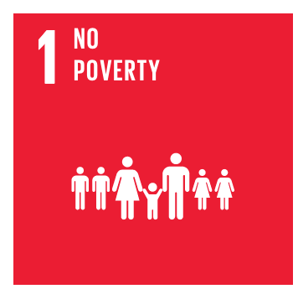 | End poverty in all its forms everywhere
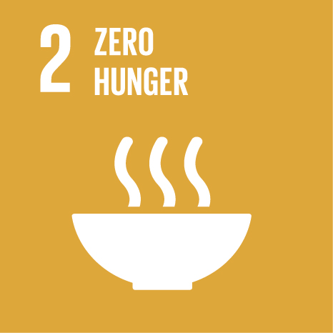 | End hunger, achieve food security and improved nutrition, and promote sustainable agriculture
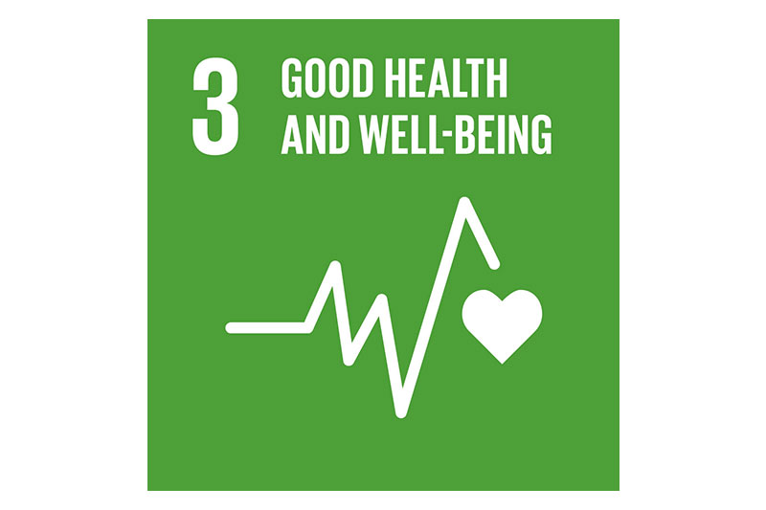 | Ensure healthy lives and promote wellbeing for all at all ages
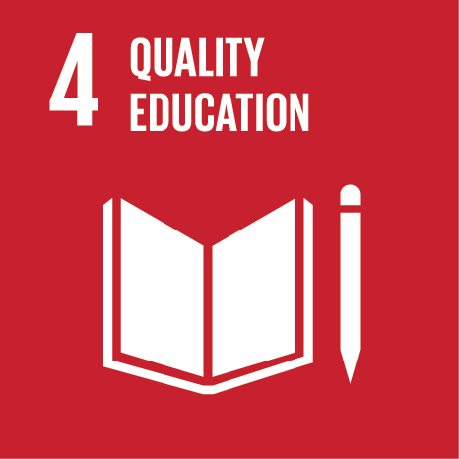 | Ensure inclusive and equitable quality education and promote lifelong learning opportunities for all
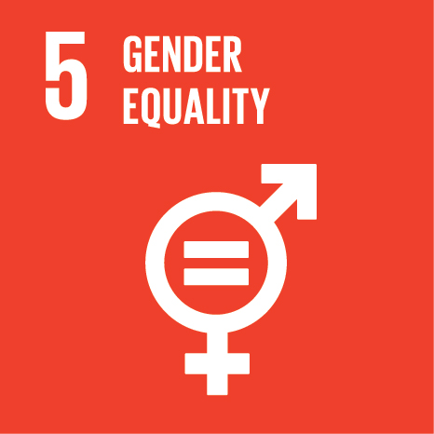 | Achieve gender equality and empower all women and girls
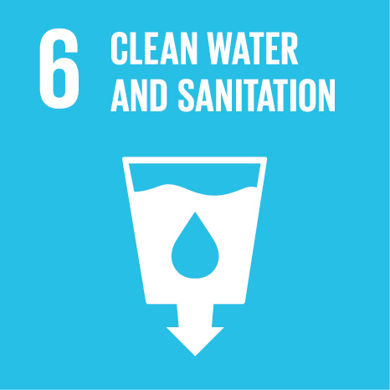 | Ensure availability and sustainable management of water and sanitation for all |  | X
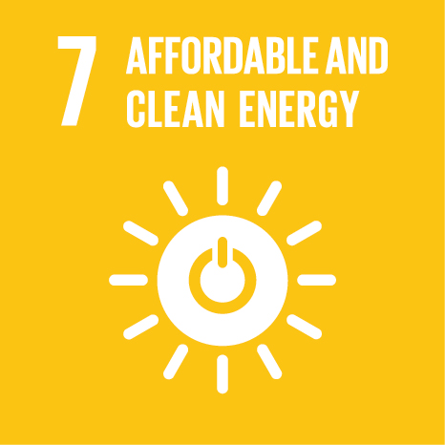 | Ensure access to affordable, reliable, sustainable and modern energy for all
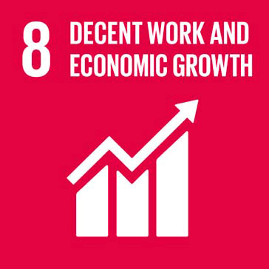 | Promote sustained, inclusive and sustainable economic growth, full and productive employment, and decent work for all |  | X
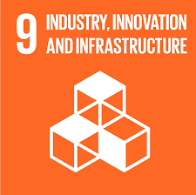 | Build resilient infrastructure, promote inclusive and sustainable industrialisation, and foster innovation |  | X
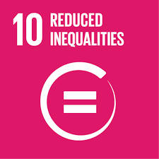 | Reduce inequality within and among countries
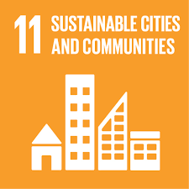 | Make cities and human settlements inclusive, safe, resilient and sustainable
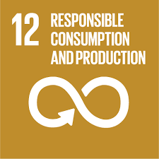 | Ensure sustainable consumption and production patterns |  | X
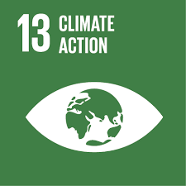 | Take urgent action to combat climate change and its impacts | X
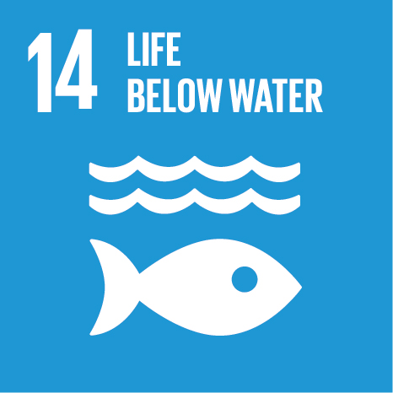 | Conserve and sustainably use the oceans, seas and marine resources for sustainable development |  | X
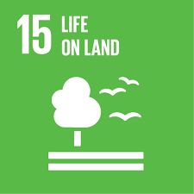 | Protect, restore and promote sustainable use of terrestrial ecosystems, sustainably manage forests, combat desertification and halt and reverse land degradation, and halt biodiversity loss | X
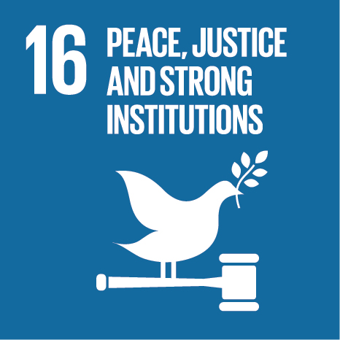 | Promote peaceful and inclusive societies for sustainable development, provide access to justice for all and build effective, accountable and inclusive institutions at all levels
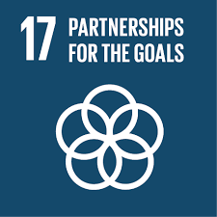 | Strengthen the means of implementation and revitalise the global partnership for sustainable development |  | X

