IPSI Case Study Summary Sheet

Please submit this form with your case study. We ask that you provide as concise responses as possible. This information will be published on the IPSI website unless otherwise requested. Please inform the IPSI Secretariat if you wish any responses not to be made public.

Basic information
Case Study Title (should be concise and approximately 2-5 words)
Deforestation around the Kahuzi-Biega National Park (PNKB).
Submission of IPSI Member Organizations
Imagine and Build the Congo of Tomorrow (ICCOD-NGO)
Other contributing organizations (IPSI members and/or non-members)
CALL FOR THE CRY OF CONGOLESE WOMEN AND CHILDREN (ACFE)
Author(s) and affiliation(s)
Imagine and Build the Congo of Tomorrow (ICCOD-NGO)
Case study format (manuscript or audiovisual) | Manuscript | Language | French
Keywords (3-5 key concepts included in the case study)
Deforestation and its consequences on the environment.
Date submitted (or updated, if updating an existing case study) |  | 9 September/2024
Web link (of the case study or responsible organization if available for more information) | https://imagine-build-congo.com/

Geographic information
Country (where the sites or activities described in the case study are located – may be multiple, or even “global”)
Democratic Republic of Congo (DR Congo)
Location (s) (in the country(ies) – leave blank if the specific location(s) cannot be identified)
Provinces of South Kivu in the Territories of Kalehe and Kabare in South Kivu Province/DR Congo.
Longitude/latitude or Google Maps link (if location is identified)
The longitude of Kahuzi-Biega National Park (PNKB) is between 27°33' and 28°46
Ecosystem (s) (please put an “x” in all that apply)
Forest | X | Meadows |  | Agricultural | X | Inland waters | x | Coastal
Arid lands |  | Mountain |  | Urban/suburban |  | Other (please specify)
Socioeconomic and environmental characteristics of the area (within 50 words)
The Kahuzi-Bega National Park (PNKB) is surrounded by several tribal communities including the indigenous pygmies, the Shi, the Havu, the Tembo, the Lega and the Nyanga. This environment being rural, has a poverty rate of 75.7%. On the environmental level, the villages surrounding the PNKB experience two types of climate: an equatorial climate with rains throughout the year in one part of the South Kivu Province and a tropical climate with a rainy season and a dry season in another part. The average annual temperatures vary between 11°C and 25°C. The latter experiences deforestation, poaching, pollution of waterways and unsanitary conditions.

Description of human-nature interactions in the region (land use, traditional resource management practices , etc. – in 50 words maximum)
- The deforestation rate is higher around the Kahuzi-Biega National Park (PNKB) which is explained by the search for wood for businesses, construction but also for energy given that the electricity supply is almost non-existent. Some members of the communities surrounding the Kahuzi-Biega National Park (PNKB) engage in poaching in this National Park.

- The absence of a policy aimed at supporting stakeholders working for the conservation and restoration of the environment.

Content

Note: The following fields are used to provide information about the activities described in the case study or the production of the case study itself, and their content may vary depending on the nature of the case study. For example, a case study of field activities may include the rationale, objectives, etc. for the activities; a case study of a SEPLS-related policy may describe the policy development process; or a case study describing a SEPLS may discuss particular practices used there. Please try to complete as many fields as possible.
Status (“in progress” or “completed”) | In progress | Period (MM/YY to MM/YY) | March 2024 – March 2025
Rationale (why the activities or policies described, or information shared in the case study are needed – within 50 words)
This study was useful to us in that it allowed us to immerse ourselves in the reality of the disastrous management of the environment in this area. This also allowed us to adapt our way of working and direct our advocacy with people of good will, institutions and organizations whose attributions include the management and preservation of the environment.
Goals (objectives of the activities or policies described, or of the production of the case study – within 50 words)
Learning about the practices and attitudes of communities living near the PNKB towards deforestation and its consequences in order to propose avenues for community solutions.
Activities and/or practices used (less than 50 words)
Communities use the following practices to degrade the environment:
- Bad agricultural methods or practices (bush fires, slash and burn, etc.)
- Wood cutting,
- Poaching,
- The unsanitary conditions,…
Monitoring methodology (e.g. GIS-based monitoring, citizen science, resilience indicators in SEPLS, survey – within 40 words)
- Literature review,
- Contacting local authorities, community leaders, schools, churches, youth, loggers, farmers to get an idea of ​​their farming methods in general and the indigenous pygmy peoples in particular who are considered guardians of the forest through a survey questionnaire to enable us to properly collect information,
- Awareness, home visits, etc.

Results (within 50 words)
- 8 meetings organized and held with local authorities and community leaders;
- 199 home visits carried out;
- 5 mass awareness sessions organized and held with Pygmy communities;
- Farmers' adherence to good agricultural practices;
- 9 ICCOD-NGO agents involved in this study trained;

Lesson learned (factors of success or failure, challenges and opportunities – in 40 words)
- This allowed us to identify our weaknesses in our way of working and to address them but also to capitalize on our strengths;
- Encourage the search for technical and financial partnerships to respond to some extent to the environmental problems experienced by the areas surrounding the Kahuzi-Biega National Park (PNKB);

Funding (any relevant information on the funding of the activities or projects described in the case study)
This study was carried out using the own funds (membership contributions) of ICCOD-ONG

Contributions to global agendas
CBD Kunming-Montreal Global Biodiversity Framework ( https://www.cbd.int/gbf/targets/ )
Please place an “x” under a number to rate how well this case study contributes to each CBD objective.
Note 1: The numerical scale ranges from 1, the lowest score, to 5, the highest score. N/A means “not applicable”.
Note 2: Please only indicate what the case study has or will actually contribute to, not what it could potentially contribute to in the future.

Target |  | Description | Contribution
 |  |  | 1 | 2 | 3 | 4 | 5 | N / A
1. Reduce threats to biodiversity | 1 | Ensure that all areas are subject to participatory, integrated and inclusive biodiversity spatial planning and/or effective management processes that take into account -land and sea use changes, in order to reduce the loss of areas of high biodiversity importance, including ecosystems of high ecological integrity, to near zero by 2030, while respecting the rights of indigenous peoples and local communities. | X
 | 2 | Ensure that by 2030, at least 30% of degraded areas of terrestrial, inland water, marine and coastal ecosystems are effectively restored to enhance biodiversity, ecosystem functions and services, ecological integrity and connectivity. |  | X
 | 3 | Ensure that, by 2030, at least 30 per cent of terrestrial and inland waters, as well as marine and coastal areas, in particular those of particular importance for biodiversity and ecosystem functions and services, are effectively conserved and managed through ecologically representative, well-connected and equitably governed systems of protected areas and other effective area-based conservation measures, recognizing indigenous and traditional territories, where appropriate, and integrated into broader land, sea and seascapes, while ensuring that any sustainable use, where appropriate, in these areas is fully consistent with conservation outcomes, recognizing and respecting the rights of indigenous peoples and local communities, including over their traditional territories. |  |  | X
 | 4 | Ensure urgent management action to halt human-induced extinction of known threatened species and for the recovery and conservation of species, particularly threatened species, to significantly reduce the risk of extinction, as well as to maintain and restore genetic diversity within and among populations of native, wild and domesticated species to maintain their adaptive potential, including through in situ and ex situ conservation and sustainable management practices, and effectively manage human-wildlife interactions to minimize human-wildlife conflict for coexistence. |  |  | X
 | 5 | Ensure that the use, harvesting and trade of wild species is sustainable, safe and legal, preventing overexploitation, minimizing impacts on non-target species and ecosystems and reducing the risk of spreading pathogens, applying the ecosystem approach, while respecting and protecting the customary sustainable use of indigenous peoples and local communities. |  |  | X
 | 6 | Eliminate, minimise, reduce and mitigate the impacts of invasive alien species on biodiversity and ecosystem services by identifying and managing pathways of introduction of alien species, preventing the introduction and establishment of priority invasive alien species, reducing the rates of introduction and establishment of other known or potential invasive alien species by at least 50% by 2030, and eradicating or controlling invasive alien species, particularly in priority sites, such as islands. |  | X
 | 7 | Reduce pollution risks and the negative impact of pollution from all sources by 2030, to levels that are not harmful to biodiversity and ecosystem functions and services, taking into account cumulative impacts, including by: (a) reducing by at least half excess nutrients lost to the environment, including through more efficient nutrient cycling and use; (b) reducing by at least half the overall risk from pesticides and highly hazardous chemicals, including through science-based integrated pest management, taking into account food security and livelihoods; and (c) preventing, reducing and working towards eliminating plastic pollution. | X
 | 8 | Minimize the impact of climate change and ocean acidification on biodiversity and increase its resilience through mitigation, adaptation and disaster risk reduction, including through nature-based solutions and/or ecosystem approaches, while minimizing negative impacts and promoting positive impacts of climate action on biodiversity. |  | X
2. Meeting the needs of populations through sustainable use and benefit sharing | 9 | Ensure that the management and use of wild species is sustainable, thereby providing social, economic and environmental benefits to people, particularly those in vulnerable situations and those most dependent on biodiversity, including through sustainable biodiversity-based activities, products and services that enhance biodiversity, and by protecting and promoting customary sustainable use by indigenous peoples and local communities. |  | X
 | 10 | Ensure that areas under agriculture, aquaculture, fisheries and forestry are managed sustainably, including through the sustainable use of biodiversity, including through a substantial increase in the application of biodiversity-friendly practices, such as sustainable intensification, agroecology and other innovative approaches, contributing to the resilience and long-term efficiency and productivity of these production systems, as well as to food security, the conservation and restoration of biodiversity and the maintenance of nature's contributions to people, including ecosystem functions and services. |  | X
 | 11 | Restore, maintain and enhance nature's contributions to people, including ecosystem functions and services, such as air, water and climate regulation, soil health, pollination and disease risk reduction, as well as protection from natural hazards and disasters, through nature-based solutions and/or ecosystem-based approaches for the benefit of all people and nature. |  |  | X
 | 12 | Significantly increase the area, quality, connectivity, access and benefits of green and blue spaces in urban and densely populated areas in a sustainable manner, integrating biodiversity conservation and sustainable use, and ensuring biodiversity-inclusive urban planning, enhancing native biodiversity, ecological connectivity and integrity, and improving human health and well-being and connection with nature, and contributing to inclusive and sustainable urbanization and the provision of ecosystem functions and services. | X
 | 13 | Take effective legal, policy, administrative and capacity-building measures at all levels, as appropriate, to ensure the fair and equitable sharing of benefits arising from the utilization of genetic resources and digital sequence information on genetic resources, as well as traditional knowledge associated with genetic resources, and facilitate appropriate access to genetic resources and, by 2030, facilitate a significant increase in shared benefits, in accordance with applicable international instruments on access and benefit-sharing. |  | X
3. Tools and solutions for implementation and integration | 14 | Ensure the full integration of biodiversity and its multiple values into policies, regulations, planning and development processes, poverty eradication strategies, strategic environmental assessments, environmental impact assessments and, where appropriate, national accounting, at all levels of government and in all sectors, in particular those with significant impacts on biodiversity, by progressively aligning all relevant public and private activities, as well as fiscal and financial flows, with the goals and targets of this framework. | X
 | 15 | Take legal, administrative or policy measures to encourage and enable businesses, and in particular to ensure that large transnational corporations and financial institutions:  (a) Regularly monitor, assess and disclose their risks, dependencies and impacts on biodiversity, including requirements applicable to all large transnational corporations and financial institutions throughout their operations, supply and value chains and portfolios;  (b) Provide consumers with the information necessary to promote sustainable consumption patterns;  (c) Report on compliance with access and benefit-sharing regulations and measures, where applicable;  in order to progressively reduce negative impacts on biodiversity, increase positive impacts, reduce biodiversity-related risks for businesses and financial institutions and promote actions aimed at ensuring sustainable production methods. | X
 | 16 | Ensure that people are encouraged and enabled to make sustainable consumption choices, including by establishing enabling policy, legislative or regulatory frameworks, improving education and access to relevant and accurate information and alternatives and, by 2030, reducing the global consumption footprint equitably, including by halving global food waste, significantly reducing overconsumption and significantly reducing waste generation, so that all people can live well in harmony with Mother Earth. |  | X
 | 17 | Establish, strengthen capacities and implement in all countries biosafety measures as defined in Article 8(g) of the Convention on Biological Diversity and measures for the management of biotechnology and the distribution of its benefits as defined in Article 19 of the Convention. |  | X
 | 18 | Identify by 2025 and eliminate, phase out or reform incentives, including subsidies, harmful to biodiversity, in a proportionate, fair, equitable, effective and equitable manner, while substantially and progressively reducing them by at least $500 billion per year by 2030, starting with the most harmful incentives, and strengthen positive incentives for the conservation and sustainable use of biodiversity. |  | X
 | 19 | Increase substantially, progressively, in an effective, timely and easily accessible manner, the level of financial resources from all sources, including domestic, international, public and private resources, in accordance with Article 20 of the Convention, to implement national biodiversity strategies and action plans, mobilizing at least $200 billion per year by 2030, including by:  (a) Increase the total amount of international financial resources for biodiversity from developed countries, including official development assistance, and from countries that voluntarily assume the obligations of developed country Parties, to developing countries, in particular least developed countries and small island developing States, as well as countries with economies in transition, to at least $20 billion per year by 2025 and to at least $30 billion per year by 2030;  (b) Significantly increase domestic resource mobilization, facilitated by the development and implementation of national biodiversity finance plans or similar instruments based on national needs, priorities and circumstances;  (c) Leverage private finance, promote blended finance, implement new and additional resource mobilization strategies and encourage private sector investment in biodiversity, including through impact funds and other instruments;  (d) Encourage innovative programmes such as payment for ecosystem services, green bonds, biodiversity credits and offsets and benefit-sharing mechanisms, with environmental and social safeguards;  (e) Optimizing co-benefits and synergies of financing targeting biodiversity and climate crises;  (f) Strengthen the role of collective actions, including those of indigenous peoples and local communities, actions centred on Mother Earth[1] and non-market approaches, including community-based management of natural resources and civil society cooperation and solidarity for the conservation of biodiversity;  (g) Improving the effectiveness, efficiency and transparency of the provision and use of resources; |  | X
 | 20 | Strengthen capacity development and strengthening, access to and transfer of technology, and promote development and access to innovation and technical and scientific cooperation, including through South-South, North-South and triangular cooperation, to meet the needs of effective implementation, particularly in developing countries, by promoting joint technology development and joint scientific research programmes for the conservation and sustainable use of biodiversity and by strengthening scientific research and monitoring capacities, commensurate with the ambition of the goals and targets of the Framework. |  | X
 | 21 | Ensure that the best available data, information and knowledge are accessible to decision-makers, practitioners and the public to guide effective and equitable governance, integrated and participatory biodiversity management, and to strengthen communication, awareness-raising, education, monitoring, research and knowledge management and, also in this context, traditional knowledge, innovations, practices and technologies of indigenous peoples and local communities should only be accessible with their free, prior and informed consent,[2] in accordance with national legislation. |  |  | X
 | 22 | Ensure full, equitable, inclusive, effective and gender-responsive representation and participation in decision-making, as well as access to justice and information related to biodiversity, of indigenous peoples and local communities, respecting their cultures and rights to lands, territories, resources and traditional knowledge, as well as of women and girls, children and youth and persons with disabilities, and ensure full protection of environmental human rights defenders. |  |  | X
 | 23 | Ensure gender equality in the implementation of the Framework through a gender-responsive approach, where all women and girls have equal opportunities and capacities to contribute to the three objectives of the Convention, including by recognizing their equal rights and access to land and natural resources and their full, equitable, meaningful and informed participation and leadership at all levels of action, engagement, policy and decision-making related to biodiversity. |  | X

UN Sustainable Development Goals (SDGs) ( https://sustainabledevelopment.un.org/sdgs )
Please check the box “directly” or “indirectly” next to each UN Sustainable Development Goal to which the work described in this case study contributes, as appropriate. Note: Please only check the goals to which the case study has actually contributed or is contributing, not those to which it could potentially contribute in the future.
ODD | Description | Direct | Indirect
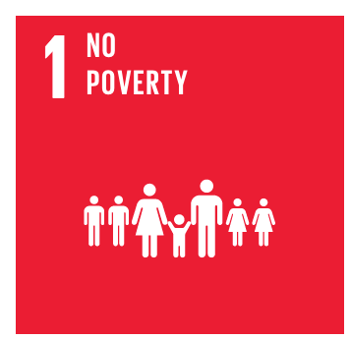 | End poverty in all its forms everywhere |  | X
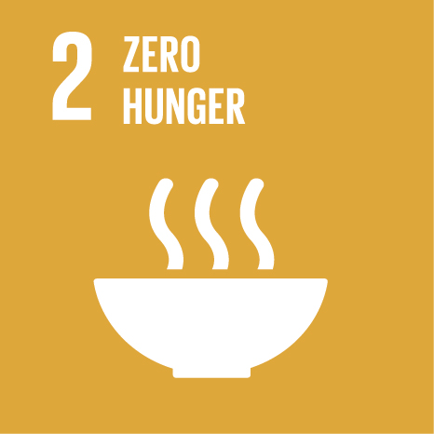 | End hunger, achieve food security and improved nutrition and promote sustainable agriculture |  | X
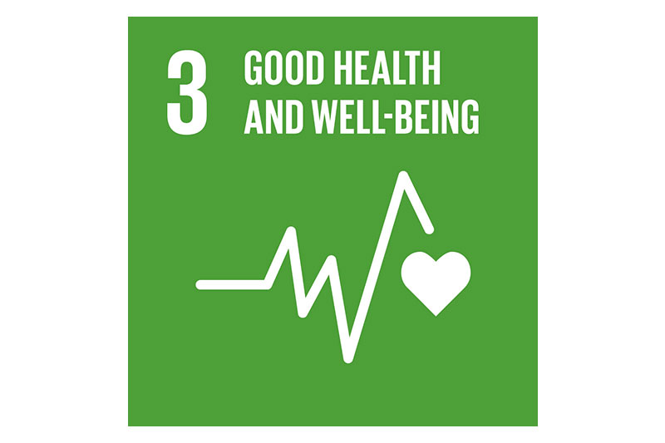 | Ensure healthy lives and promote well-being for all at all ages | X
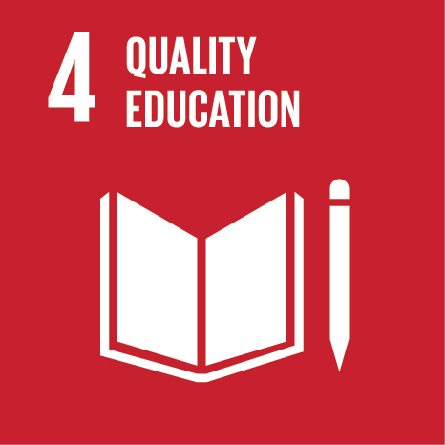 | Ensure inclusive and equitable quality education and promote lifelong learning opportunities for all |  | X
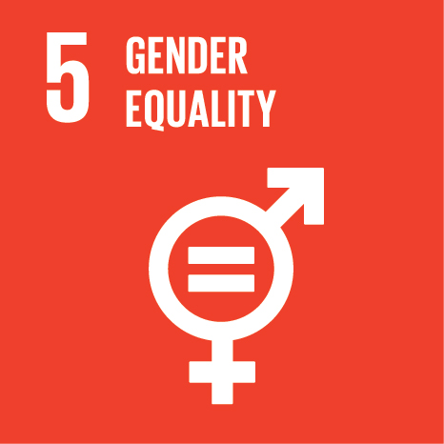 | Achieve gender equality and empower all women and girls |  | X
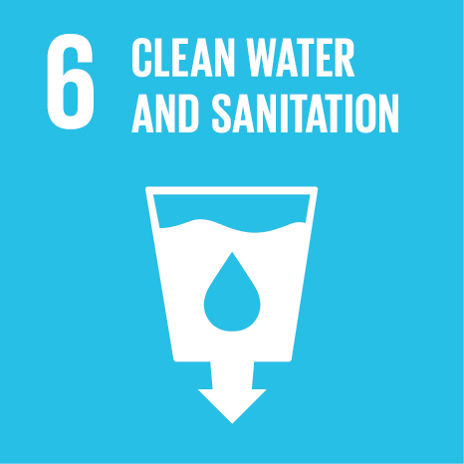 | Ensure the availability and sustainable management of water and sanitation for all |  | X
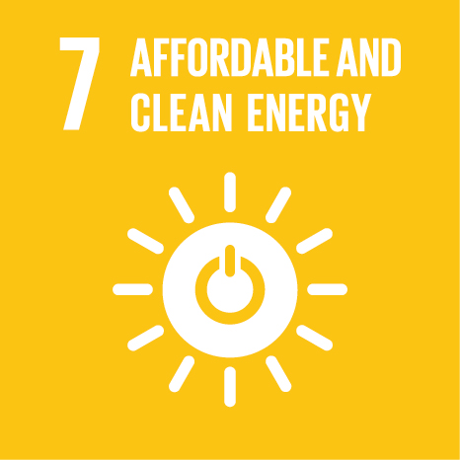 | Ensure access for all to affordable, reliable, sustainable and modern energy |  | X
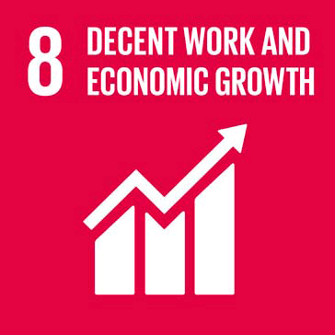 | Promote sustained, inclusive and sustainable economic growth, full and productive employment and decent work for all |  | X
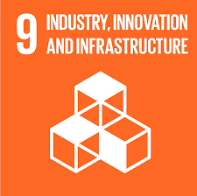 | Building resilient infrastructure, promoting inclusive and sustainable industrialization and fostering innovation |  | X
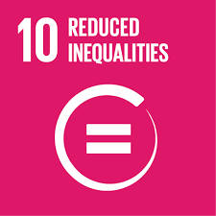 | Reducing inequalities within and between countries |  | X
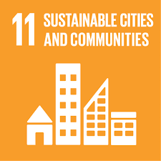 | Making cities and human settlements inclusive, safe, resilient and sustainable |  | X
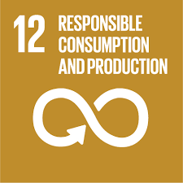 | Ensuring sustainable consumption and production patterns |  | X
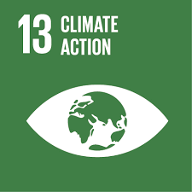 | Take urgent action to combat climate change and its consequences |  | X
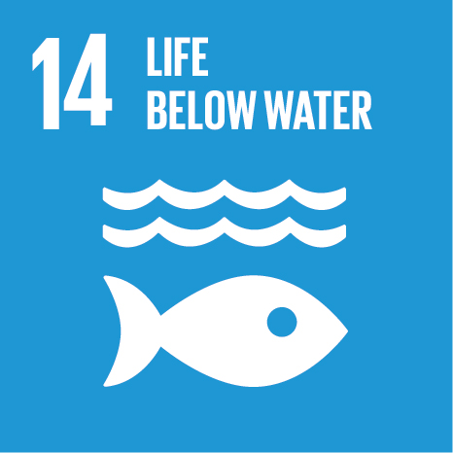 | Conserve and sustainably use the oceans, seas and marine resources for sustainable development |  | X
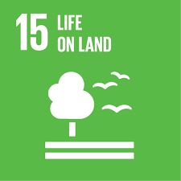 | Protect, restore and promote sustainable use of terrestrial ecosystems, sustainably manage forests, combat desertification, halt and reverse land degradation and halt biodiversity loss |  | X
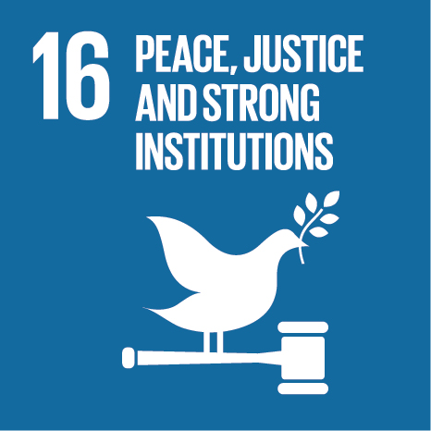 | Promote peaceful and inclusive societies for sustainable development, ensure access to justice for all and build effective, accountable and inclusive institutions at all levels |  | X
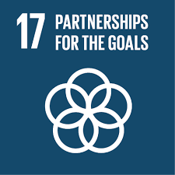 | Strengthening the means of implementation and revitalizing the global partnership for sustainable development |  | X

