IPSI Case Study Summary Sheet
Basic Information
Title of case study | COMDEKS Project: Natewa-Tunuloa Peninsula
Submitting IPSI member organization(s) |  | United Nations Development Programme (UNDP)
Other contributing organization(s) |  | Ministry of the Environment Japan (MOEJ), SCBD, UNU
Author(s) and affiliation(s) |  | United Nations Development Programme (UNDP)
Format of case study | Manuscript |  | Language | English
Keywords | Food security, Coastal ecosystems, Poverty alleviation
Date of submission | 6 March 2017
Web link | http://collections.unu.edu/eserv/UNU:6011/communities_in_action_comdeks.pdf#page=66

Geographical Information
Country |  |  | Fiji |  | Location(s) | Cakaudrove Province
Longitude/latitude or Google Maps link |  |  |  |  | https://www.google.com/maps/@-16.5987886,179.7577352,11.25z?hl=en
Ecosystem(s)
Forest | x | Grassland |  | x | Agricultural | x | In-land water |  | Coastal | x
Dryland |  | Mountain |  |  | Urban/peri-urban |  | Other
Socioeconomic and environmental characteristics of the area
The combination of climate and topography provides for a variety of natural terrestrial habitats and ecosystems, from littoral coastal shrub-land and mangroves, to low and montane forests. The estimated forest cover area for the landscape is 70 percent, and the remaining 30 percent includes coconut plantations, community agricultural areas, and grasslands.
Description of human-nature interactions in the area
Industry within the landscape is almost non-existent, and major activities are still agriculture-based with limited opportunities for non-farm employment. The major source of revenue for communities is the cultivation of dalo (Colocasia esculenta) and yaqona (Piper methysticum). Copra is also harvested as a cash crop and honey has recently appeared as a lucrative source of income for the area. Much of what is cultivated in the area is for subsistence. The landscape has been listed as a site of national significance under the Fiji National Biodiversity Action Plan since it is one of the last places in Fiji that retains forest with an intact range from lowland to montane habitats.

Contents
Status | Ongoing |  | Period | 06/2011 –
Rationale
The target landscape was selected firstly due to the status of the terrestrial and marine environments as national and global biodiversity hotspots; secondly, to address poverty and provide viable income options for communities within the landscape; thirdly to document and revive traditional practices, and to meld local knowledge with modern concepts and technology to revitalize the landscape and its communities.
Objectives
Protect, restore, or effectively place critical ecosystems and habitats under an acceptable and recognized sustainable natural resource management regime; Maintain and enhance agricultural biodiversity and productivity through sustainable land use practices and approaches; Enhance, improve, and replicate local livelihoods within a sustainable exploitation context through community-driven income generation and development initiatives; Strengthen capacity to enhance participatory planning on conservation and sustainable production issues affecting landscape resilience.
Activities and/or practices employed
Developing comprehensive land use maps of the target landscape; Developing an institutional platform at the landscape level; Capacity building among village leaders and natural resources committee representatives; Mainstreaming gender into local community development and natural resource planning; Rejuvenating abandoned lands for forestry and farm income
Results
A forest and agricultural mapping exercise was conducted; Natural Resources and Environment Committees were established in many villages; At the national level, a technical advisory group was formed; Representatives took part in consultations with technical advisory personnel; A workshop on gender and climate change was attended by 60 men and women from the villages; Replanting of 1000 ha of former pine plantation with commercial tree crops has begun, as well as the replanting of 500 ha of former crop lands with dalo and copra
Lessons learned
The integrated approach to landscape development is a key factor in community acceptance; Weaknesses in the local institutional framework and the capacities of CBOs to generate high-quality project proposals has to be dealt with before local project planning can really commence; Engagement of technical service providers, advisory groups, and other partners is critical from the onset; There is a need to integrate traditional leadership into overall governance; Gender sensitivity and inclusivity is imperative to meet target goals
Key messages
Activities are still in the early implementation stages. The completion of two broad scale capacity-building and information gathering projects has laid a good foundation for bringing about landscape-wide effects. The information presented in the maps has allowed land and resource owners to appreciate the limitations that land and soil types can have on the interventions they make on their land. Creating an institutional structure in each village (i.e., Village Development and Natural Resources and Environment Committees) is a clear starting point for the development of functional governance mechanisms at the landscape level.
Relationship to other IPSI activities |  | This case study is part of the COMDEKS Project (IPSI Collaborative Activity)
Funding
Funding of USD 280,000.00 was provided by the Japan Biodiversity Fund through the GEF Small Grants Programme for COMDEKS Fiji.

Contributions to Global Agendas
The table below shows based on the self-evaluation by author(s). and indicates the “direct” or “indirect” contributions to the following global agendas respectively to which the work described in this case study contributes to.

CBD Aichi Biodiversity Targets (https://www.cbd.int/sp/targets/)
Strategic Goal A |  |  |  | Strategic Goal B
Strategic Goal C |  |  | Strategic Goal D |  |  | Strategic Goal E

UN Sustainable Development Goals (SDGs) (https://sustainabledevelopment.un.org/sdgs)
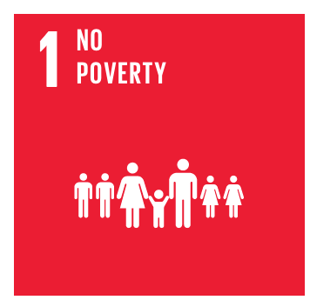 | 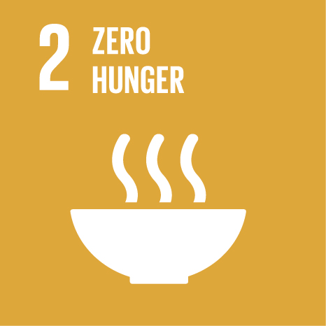 | 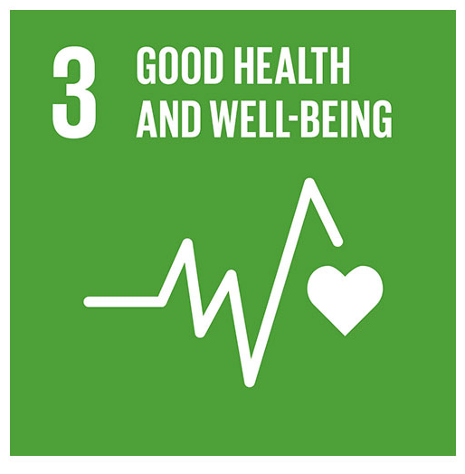 | 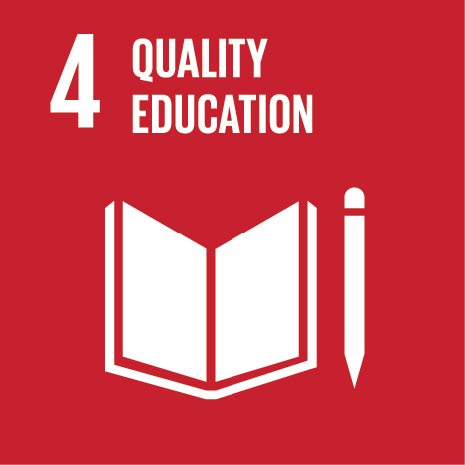 | 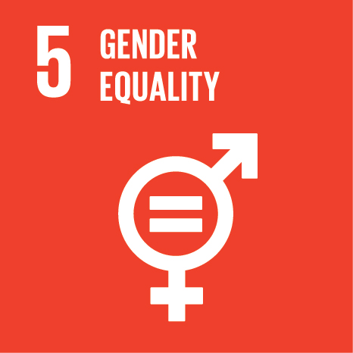 | 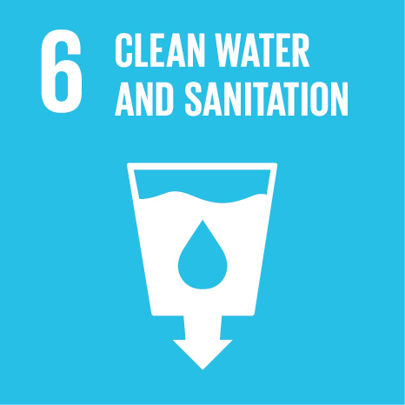 | 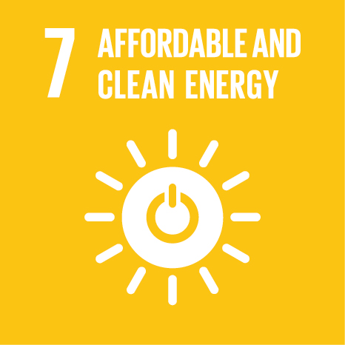 | 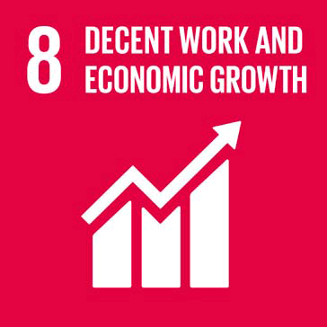 | 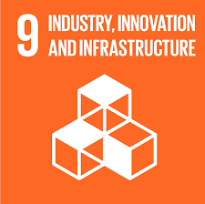
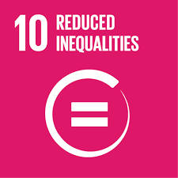 | 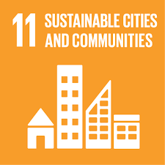 | 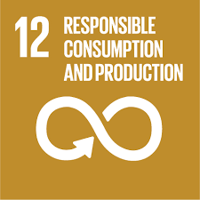 | 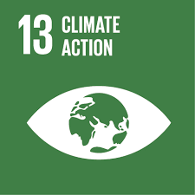 | 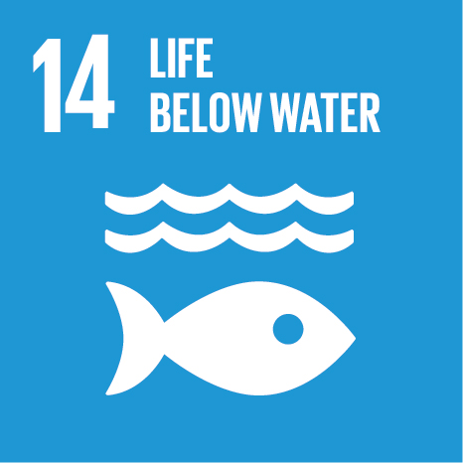 | 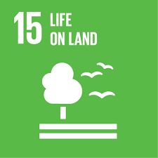 | 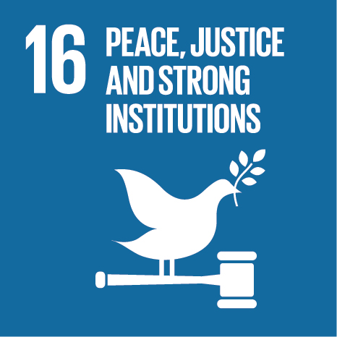 | 